## **Deliverable 1 Report - Gun Violence - Team 3**

### **Datasets used:**

1. Shots Fired
   1. 7553 rows and 5 columns
   2. 3 rows with at least one empty value
2. Shootings
   1. 1798 rows and 9 columns
   2. 46 rows with at least one empty value
3. City Council
   1. 9 rows and 37 columns in this dataset

### **Assumption made:**

1. District 4 is made up of Boston Police Districts B2, B3, C11 and E5

### **Graphs plotted:**

1. Number of Gun Violence Incidents in Each District for Each Year
2. The ratio of Gun Violence Per Year (District 4 vs. Rest of Boston)
3. Number of Incidents by District and Race
4. Percentage of Shooting Incidents by Victim Race
5. Sanity check plot for the City Council dataset shapefile
6. The district-wise intensity of gun violence w.r.t incidents count

### **Observations:**

#### **What question we wanted to answer**:

What is the rate of gun violence in District 4? How does this compare to the rest of the city?

#### **What we observed:**

**Number of Gun Violence Incidents in Each District for Each Year**

These bar charts show the number of gun violence incidents per year for each police district. Colored in red are the police districts that are inside the council city district 4.

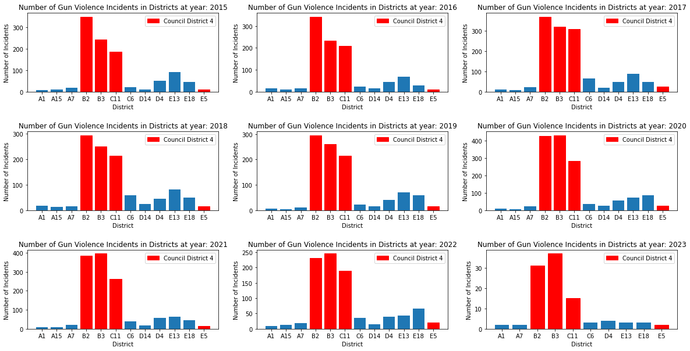

Key Findings from this graph:

* All the districts associated with the council city district 4 have the highest rate of gun violence compared to the rest of the districts.
* Every year the trend of gun violence in each police district is fairly unchanging. This showcases that gun violence is not inherently dependent on the timeframe.

**The ratio of Gun Violence Per Year (District 4 vs. Rest of Boston)**

The bar chart below shows the ratio of gun violence incidents per year for district 4 versus the rest of Boston. Colored in blue are the police districts that form District 4.

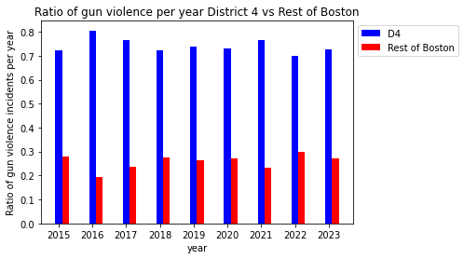

Key Findings from this graph:

* District 4 has the highest ratio of gun violence every single year from 2015 to 2023.
* The disparity in the ratio of gun violence between District 4 and the rest of Boston ranges from slightly more than twice to slightly more than 4 times.
* The highest ratio of gun violence occurred in 2016, with 80% of gun violence in that year occurring in District 4.
* In 2023 alone, 70% of gun violence thus far occurred in District 4.

**Number of Incidents by District and Race:**

This stacked bar chart shows the number of incidents per district and victim race. Here, each district is represented by a different color in the chart and divided into segments representing the number of incidents for each victim race.

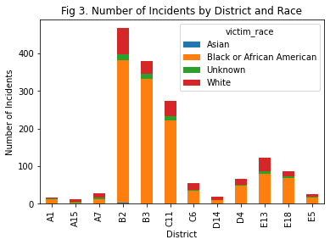

Key Findings from this graph:

1. Black or African American victims are disproportionately affected by shooting incidents, with significantly higher numbers compared to other races.
2. Unknown ethnicity victims are present in relatively high numbers, indicating a need for improved reporting and data collection methods.
3. Incidents involving Asian victims are almost negligible.

**Percentage of Shooting Incidents by Victim Race:**

In the D4 district, most shooting incidents involve Black or African American victims, totaling 1172 incidents. White victims come in second, with a much smaller number of incidents (178), followed by Unknown (46) and Asian victims (6).

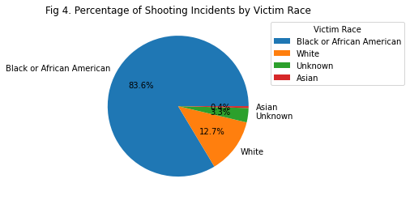

Key Findings from this graph:

1. This data suggests that Black or African American residents in the D4 district are disproportionately affected by shooting incidents. Further analysis and investigation are needed to understand the underlying reasons for this disparity and to develop effective strategies for reducing gun violence in the area.

**Sanity check map plot for the City Council dataset shapefile:**

This plot is for sanity-checking the city council dataset shapefile to ensure we have bounded shapes(territories) with distinct boundaries and appropriate labels.

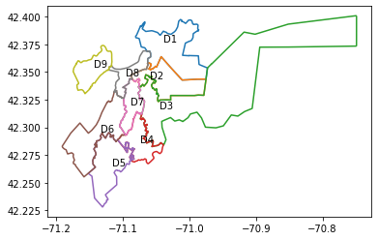

**The district-wise intensity of gun violence w.r.t incidents count:**

This map plot shows us the district-wise gun violence intensity with the help of color gradients. Here, every district is marked with a color based on the count of gun violence incidents in that district compared to other districts.

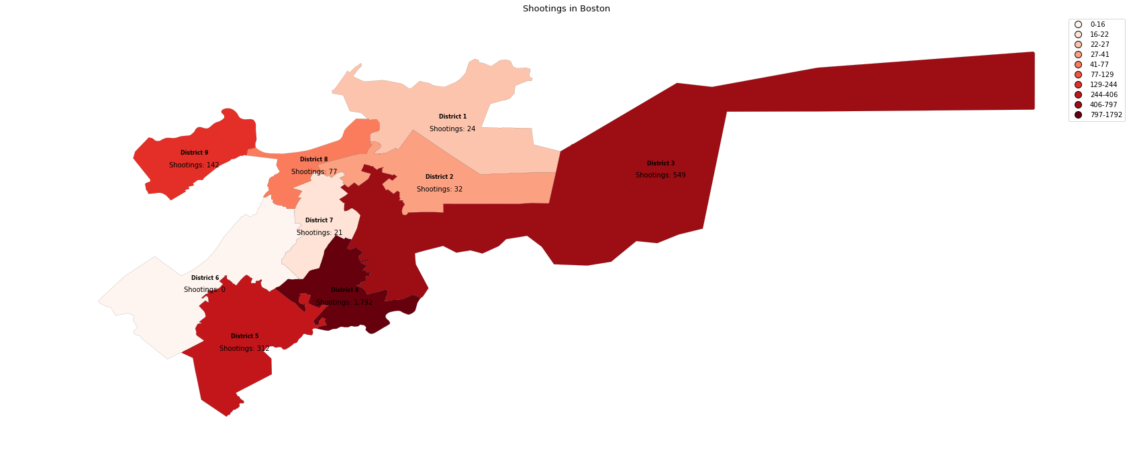

Key findings from this map plot:

1. This plot helps us understand the importance of this project as it demonstrates the stark difference in the intensity of gun violence incidents in District 4 versus the rest of Boston.
2. In the D4 district, we see an increase of more than twice the number of incidents compared to the second most affected district (District 3).